**Website Report**

Table of Contents

ADZilla 2

Introduction 2

USE 2

➢ Some Features 3

➢ Our Services 3

➢ Discounted Price 3

➢ Video Games 4

➢ Watches 4

➢ Membership Card 4

➢ Free Delivery 4

➢ Place Online Order 4

➢ Return Policy 5

➢ Become Online seller 5

➢ Lucky Draw 5

➢ No fake No scam 5

➢ Featured Products 6

➢ Useful Links 6

# ADZilla

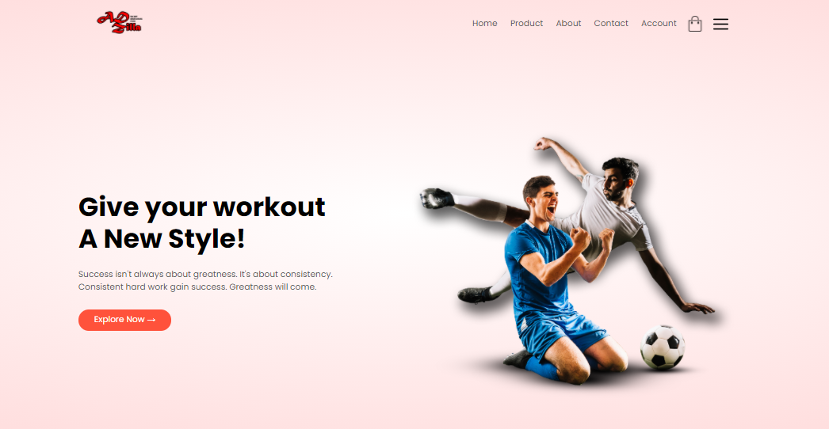

# Introduction

Our website in the name of ADZilla in which we do all kinds of sales.This is a classified ad website .In this website any user can place their product for sell and others can browse the website for buying products according to their need.

## USE

You can place your ad by clicking on publish your ad for free

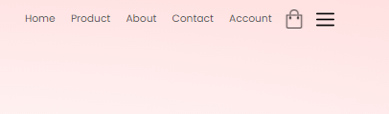

Then Enter Information about your product such as name, pictures, description etc. Then enter information about you such as your name, address, email, contact no etc.

And publish your ad so, other users can see your ad and contact you if they want to purchase your product

## Some Features

* Anyone can place his/her ad without limitations
* Responsive Interface
* Easy To Use
* Vast range of products for sell/purchase

## Our Services

Our Services include almost all things such as household (Domestic Help), Cloths, Health equipments, Electronic equipments, Stationary, Children toys, Different kind of food etc. Some cloths Items photos are given below:



## Discounted Price

ADZilla give you the very reasonable price .You may compare the prices to other stores. And every Sunday there is a big sale offer for Childers only. And 5% discount on every item for students.

## Video Games

All type of video games is available here. If somebody buys 5 packs of games at a time we give then 1 mini video game free. If anyone wants to play trial of any game there is video games machine available.

* **Watches**

All type of watches is available here.

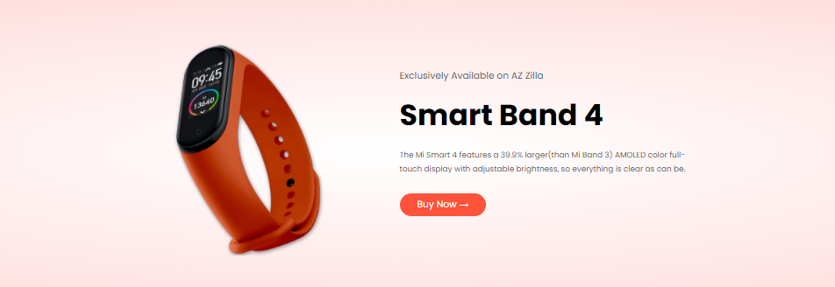

## Membership Card

ADZilla Store provides a membership card for those customers who purchase items for more than 50$(dollar) a month.The membership card has an expiry date. After one year this card will be expired and members can renew this card by visiting our ADZilla store.

## Free Delivery

ADZilla store provides free delivery in the city. If anyone places an order he/she wants that order is delivered to his house then he/she should pay 5% before placing an order.

## Place Online Order

We provide facilities to everyone if anyone busy and he/she has no time to visit the store and buy items. For those peoples, our store provides an online method. They can place an order to our store (ADZilla) app. After two-three hours the order is delivered to their given address.

## Return Policy

We provide facilities to everyone, if anyone buys the item from the store by mistake, so there is the best solution for those peoples they come to store with the bill, after verifying that item (that it belongs to our store). After 1-2 minutes, we change the product or give back payment. If there is any issue in any of our items, you can return the refund to me and get the money back.

## Become Online seller

If anyone wants to sell items with us. There is some rule:

1. If you want to work with us online then go to our website and create an account or login.
2. If he/she sells items that belong to clothes then he/she pays 25% from the profit.
3. If he/she sells items that belong to electronic then he/she pays 20.5% from the profit.
4. And selling other items except (clothes and electronics) he/she pays 10% only.

## Lucky Draw

In every last week of the month, there is a lucky draw in the store. To become the participant follow some rules:

* You should buy things from our store every week.
* You install our app and order.
* Bill is required to be a part of the lucky draw.

## No fake No scam

1. Everything is branded in our store.
2. We do not sell bad items.

You are very happy after visiting our store. And all our products in our store will cost less than other stores

* **Featured Products:**

We provide facilities to everyone Featured product deals for our new costumers.

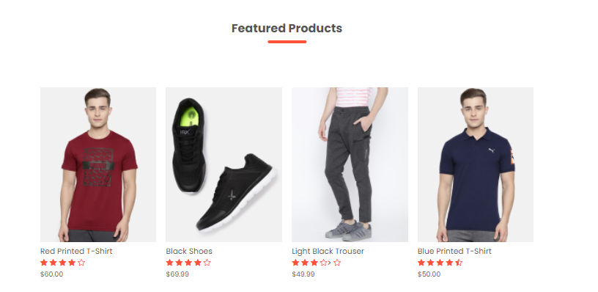

* **Useful Link & App**

We provide facilities to everyone Our useful links as well mobile application free!

